LET’S TRIP: Build Your Itinerary

Palak Amin, Shalvi Desai

KDPDIT, CSPIT, CHARUSAT  
Changa

17it005@charusat.edu.in

17it019@charusat.edu.in

Abstract— We know how big of a hassle it is, to plan a vacation in

another city, amongst different people with varied culture and

civilization. Let’s Trip is a solution to all such problems. It is a

platform which combines all the essential information regarding

food, activities, shopping and places to visit along with ratings

and reviews from different acclaimed travel portals, food

bloggers and websites for adventure sports. Thus, it is one such

solution to make your own itinerary.

Keywords— Ratings, Data collection, Reviews, scrapping

1. Introduction

We have all sorts of travel portals like Make My Trip, Yatra, Goibibio and lot more, but what if we could plan trip all by ourselves without loosing ample amount of money to a third party service and get it all done on a single platform like Let’s Trip.

*A. Project Overview*

This application will ease up the struggle of the users to search about exotic sights or adventurous activities or quench their thirst to have their meals at the most exquisite places or shop for all the traditional antiques depicting history of the town.

*B. Scope*

Entire application is divided in four segments namely,

1.) Places, 2) Shopping, 3) Activities 4) Food. Here all the essential details are mentioned such as visiting hours for all the places, expertise of the local artisans and things to buy, some must try activities and their approximate costs and guidelines and in the food section one can look for cuisine of one’s own choice, ambience and pricing for the same , everything on one

application.

*C. Objective*

The major objective of this project is to save our users from wasting all their time and effort for planning an ideal trip or to stop them from overpaying for their vacation. We want to help all the people who are engrossed in their monotonous routine to plan a stress-free and relaxing vacation in a money friendly manner and customize it with their personal interest with a single tap.

1. System Analysis
2. System Inclusions

The system consists of the 4 tabs, that basically contain information about the Food, Shopping, Activities to do and Places to visit at some particular place.

It starts with a launching activity where user has to search for, or select a city they are looking to explore. If the city is included into our database, the activity will shift to the 4 main tabs with all the information required for spending a good time in the city. We also provide an option for suggestions, so, if we miss out on any place, that the user thinks is interesting and we should cover in our application. For that, the user first has to login into the application for reliability purposes. All the data is retrieved from Firestore Cloud and it also supports offline data availability, so, once loaded the data will be visible even if internet connectivity is lost.

1. Tools & Technology

Following are the tools and technology used for implementing the project:

* PyCharm
* Android Studio
* Visual Studio Code
* CSVtoJson converter
* npm(node)
* Firebase Cloud Firestore

1. System Design
2. Flow of System

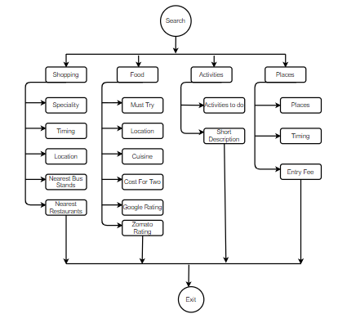

1. Major Functionality

1) *Shopping Tab:* A tab that contains basic details regarding the shopping sites for a particular city searched.

2) *Activities Tab:* A tab that contains information about the fun activities to do when u visit some city.

*3)Food Tab:* This tab contains the famous restaurants with budget constraints and cuisines you like all sorted.

*4)Places Tab:* This tab consists of the most common sites that people look for. Sight-seeing. Along with the entry fee and visiting hours all at one place.

1. GUI Forms

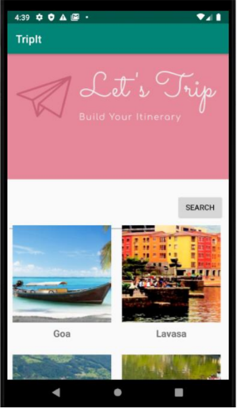

Figure 1: Search Page

1. Implementation

We have used firestore cloud database and retrieve data into our application with proper intent and methodology using Java in android studio. We have used python scripts to scrape data from different sites.

* 1. *Snapshots of project*

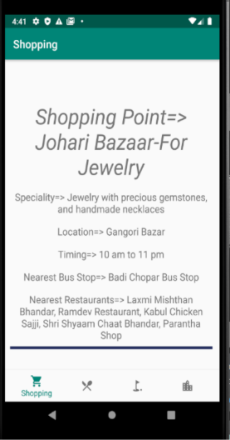

Figure 2: Shopping Tab

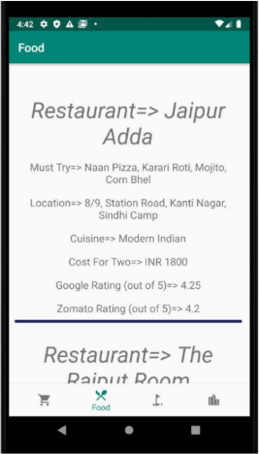

Figure 3: Food Tab

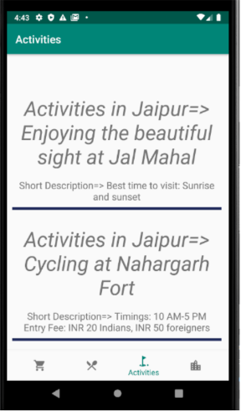

Figure 4: Activities Tab

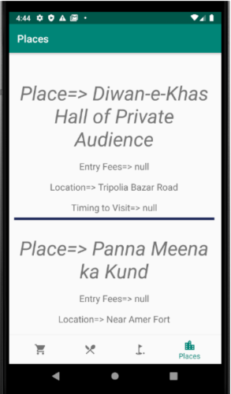

Figure 5: Place Tab

1. Constraints and Future Enhancement

In current scenario we have used to web scraping for the data collection of our application which is static and can get outdated very soon if it’s not regularly updated. We can use the technique of web crawling which creates a bot and keeps following the hyperlinks if content is updated, hence we can increase the reliability of our data using this technique. We can provide login to all the users which can be utilized by the users to make an itinerary with dates and timings for their vacation and can also be used to set reminders and announce weather forecast around that course of time and can give valuable insight to our user. We can recommend our user with different destinations to visit based on their past history enhancing their user experience.

1. Conclusion

The application Let’s Trip is going to be of great help when it comes to planning your trip on your own, decide where you want to go, what you want to do, and what time you want to spend (itinerary). All of this stuff are available on google but you have to surf through minimum 14-15 sites but with this application, everything is available at one place just one click away. This application can save

Acknowledgment

We, the creator of a “Let’s Trip: Build your itinerary”, with immense pleasure and commitment would like to present the project assignment. The development of this project has given us wide opportunity to think, implement and interact with various aspects of management skills as well as the new emerging technologies. Every work that one completes successfully stands on the constant encouragement, good will and support of the people around. We hereby avail this opportunity to express our gratitude to number of people who extended their valuable time, full support and cooperation in developing the project. We express deep sense of gratitude towards our Head of the IT Department, Dr. Parth Shah and project guides Prof. Sagar Patel and Prof. Madhav Ajwalia for the support during the whole session of study and development. It is because of them, that We were prompted to do hard work and adopting new technologies.